**Market Analysis in Chennai for Hotel Establishment**

**-By S. Saravanan**

**Introduction**

Starting the own Business is a dream for many people. Extending the existing business shows the hard work and talent of the people in the company. Like that, One of the Businessman Mr.X, Who is a successful businessman in Hotel. He has branches in Karnataka, Andhra Pradesh and Kerala in India. He wanted to extend his business in Tamil Nadu. So, He approached me to do a detailed Market Analysis to figure out the best location for establishing the Hotel. So, I decided to do the Market Analysis based on the data obtained from the Open Source such as Foursquare API and Google. This report will be helpful for those who wants to start their business in Chennai and this report helps to understand the various successful business going in and around Chennai.

**Data Scrapping**

The list of Zones and locations in Chennai was obtained from Wikipedia. Chennai has around 150 areas. Chennai is the smallest district and It has the Highest Population Density. The FourSquare API was used in order to find out the location coordinates, Venues Available and its Category types, etc. FourSquare has a Standard plan category where we can do 100 regular calls per day and 2 Premium Calls per day.

**Methodology**

Here, I have used KMeansClustering Algorithm for clustering the areas. I clustered the areas into 8 Segments. I have chosen the K value using Elbow Method.

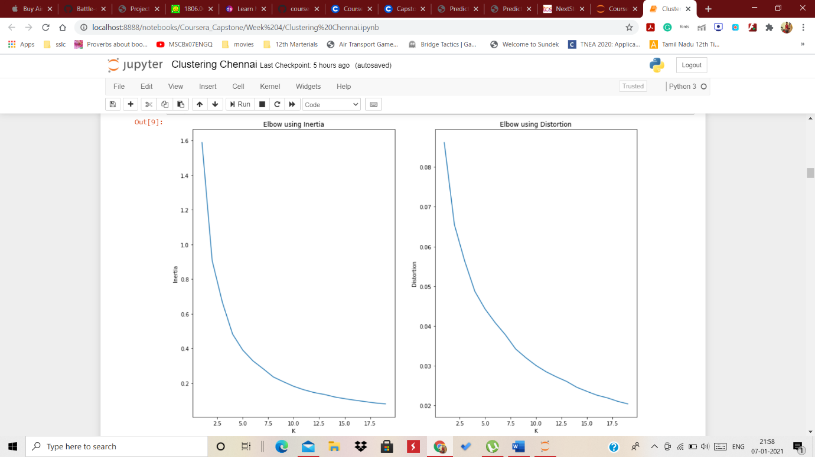

After Clustering the areas, I have plotted the areas using Folium Library.

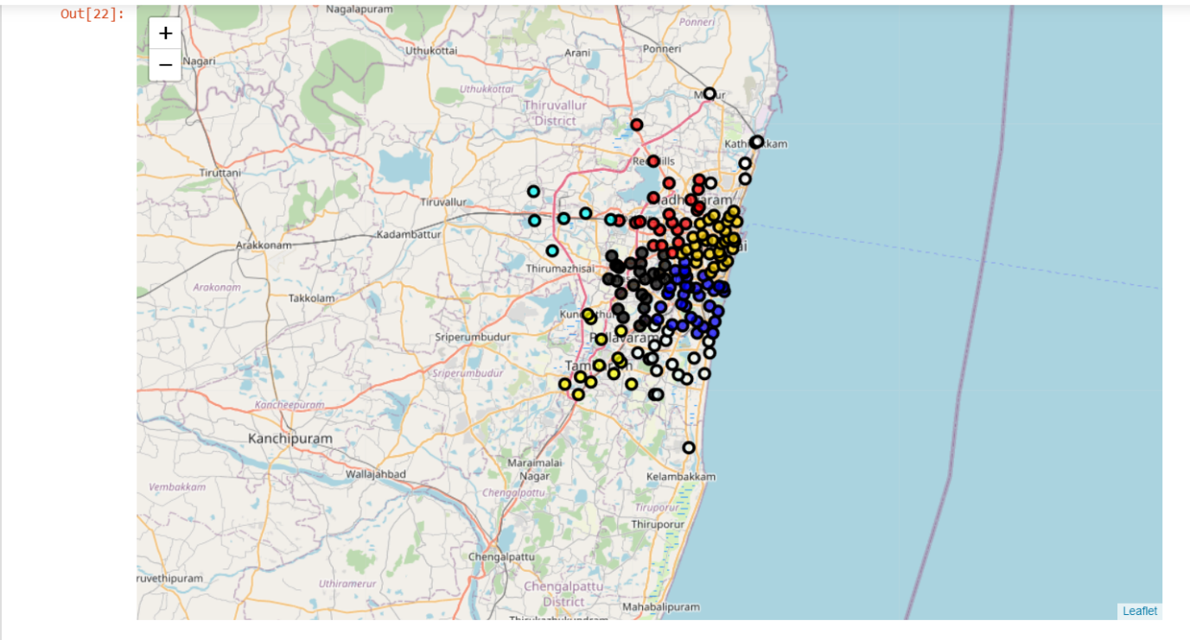

**Discussion and Result Analysis**

After Clustering based on Latitude and Longitude Values of each areas, We have obtained Venues, Venue Categories from Foursquare API. After doing all the necessary steps, I have framed a dataframe which contains the count of various caregories of venues in each cluster.

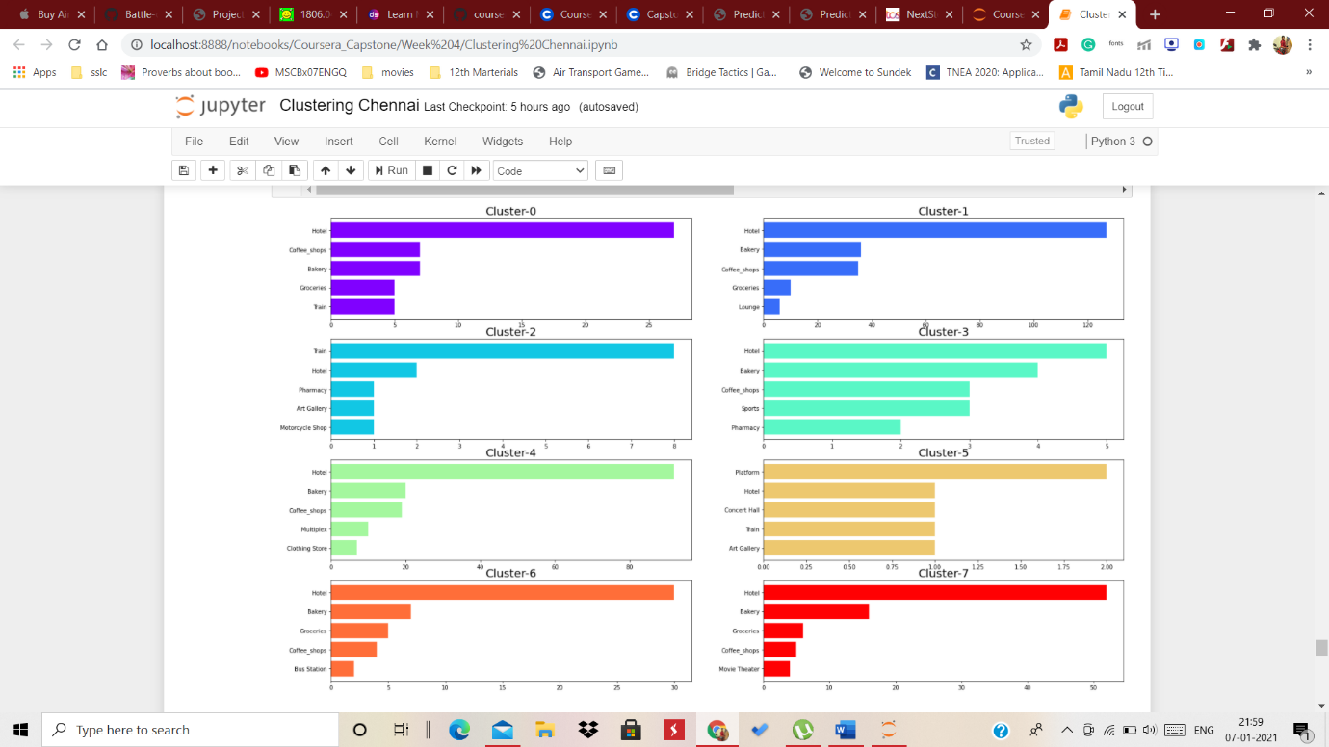

From the above bar graph, I have found that From the above bar graph, we can able to see that Cluster-1,2,4,7 Have more than 50 Hotels. So, Those places not the right choice for Hotel. Cluster-5 is somehow outside from the center of the city. So, If the customer wants to establish their hotel in a remote place, It will be the Best Choice for them. Cluster-3 and 6 is in the City, But Still, It has very limited hotels. So, The customer can look for that cluster too. Cluster-0 is in the center of city and it has variety styles of hotels. So, The customer has to think a lot in establishing in this sector

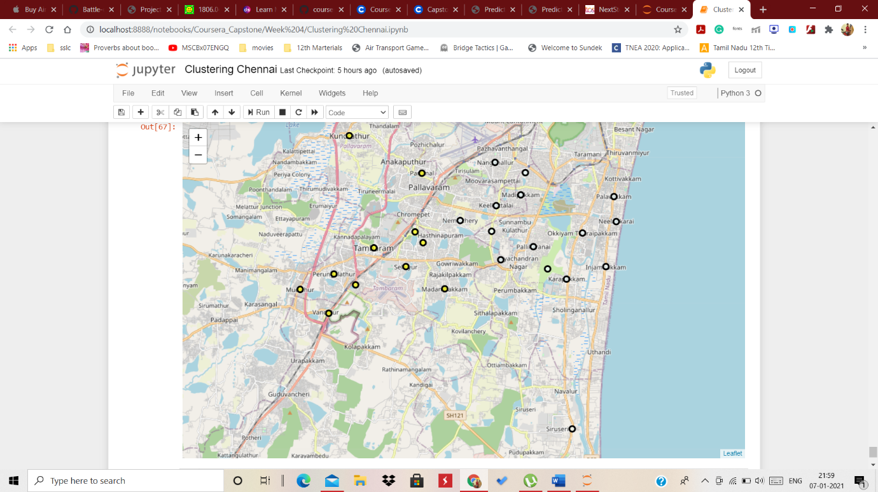

**Conclusion**

After the detailed Analysis, I have found that It is good to setup hotel in Cluster 3 and/or Cluster 6 as these areas are easily connected to the centre of the city and this region has more population Density. I have listed the areas comes under Cluster 3 and 6

